

**Supporting your child to learn at home during coronavirus crisis**

**Introduction**

**What is in this pack?**

We are hopeful that this toolkit will help support your child/YP at home during this time of uncertainty. For an autistic child, YP or adult visual supports can help to decrease anxiety and increase independence across all settings. This toolkit provides you with all that you will need to help structure your child’s day at home, no matter his/her age.

**Contents**

1. ***Planning your days***. Putting structure into the day will help reduce anxiety so creating a schedule/timetable can really help. This section includes templates, and symbols for activities for those who need it.
2. ***Visual supports*:** to support activities and smaller ‘chunks’ of time, ready for the activity ideas below. This includes now-next visual, mini schedule and a to do list which you can use according to what suits your child/YP.
3. ***Activity ideas*.** This section provides some key themes for activities that can help support learning and engagement at home.
4. ***Choice board*.** If your child is overwhelmed by too many choices OR some of the schedule pieces are not options in your home, you can cut out a smaller number of choices and stick them on this board for your child to choose from. This can also be used as a reward choice board.
5. ***Keeping track****.* If you would like to keep track of which activities you’ve completed, you can use this visual
6. ***Reward progress*.** If your YP would benefit from working towards a goal/reward, here are some visuals that you can use for this.



West Berks Autism Team 06/01/21

1. Planning your day

Choose from one of the following templates – or create your own! See also the additional attached file for more options of templates.

**How to use**

* Print. Alternatively, edit in a preferred format if no printer e.g. PowerPoint.
* Order the selected events of the day/week onto the timetable of your choice or blank sheet titled ‘My day’. It may need to be longer than one page, and an extra pack is included with a weekly schedule if preferred. For some students, timetables on phones will work well, with reminders.
* Be sure to have clear ideas of what activities are good during breaks, and try and schedule in sensory activities to help regulate.
* Go through the schedule with your child/YP at the start of the day. They may need you to break it down so that only a few things are shown at a time.
* If you child/YP is using ‘my day’, then draw your child’s attention to each activity as it happens, showing them the symbol on the ‘My day’ sheet before starting.
* As each activity on ‘my day’ finishes, explain that this is ‘finished’ and take this off the schedule. Ideally put that symbol in a zip wallet/container with the ‘finished’ symbol stuck on the front.
* The ‘next’ activity should now be at the start of the top of the list of symbols.

|  |  |  |
| --- | --- | --- |
| **Day:________________________** | | |
| **TIME** | **Activity** | **Topic** |
|  | Breakfast |  |
|  | Session 1 |  |
|  | Break |  |
|  | Session 2 |  |
|  | Lunch |  |
|  | Session 3 |  |
|  | Break |  |
|  | Session 4 |  |
|  | Dinner |  |

**Today’s timetable**

|  |  |  |
| --- | --- | --- |
| Topic |  | Time |
|  |  |  |
|  |  |  |
|  |  |  |
|  |  |  |
|  |  |  |
|  |  |  |
|  |  |  |
|  |  |  |

|  |  |  |
| --- | --- | --- |
| Topic |  | Time |
|  |  |  |
|  |  |  |
|  |  |  |
|  |  |  |
|  |  |  |
|  |  |  |
|  |  |  |
|  |  |  |



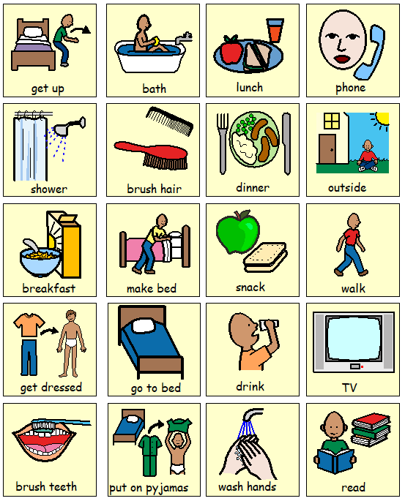

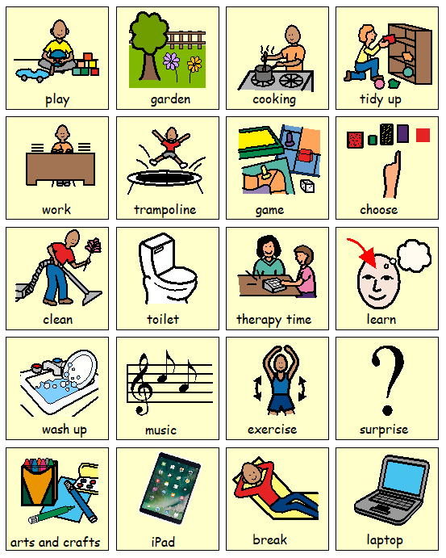

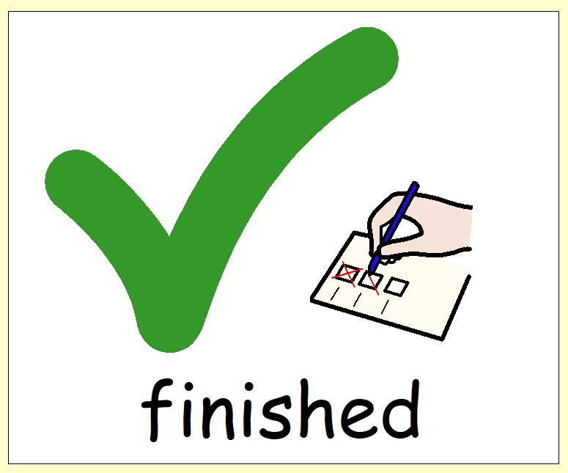

2. Visual Supports

Use what is relevant for your child/YP. You can print these off and write in them, or use symbols/pictures. Colour coding may help.

School can advise.

|  |
| --- |
| C:\Users\francesca spong\Downloads\download.png Now |
|  |
| C:\Users\francesca spong\Downloads\download.png Next |
|  |

|  |  |  |
| --- | --- | --- |
| Now |  | |
| : |  |
|  | |
|  |  | |
| Next |  | |
| : |  |
|  | |
|  |  | |

Mini schedule (e.g. to complete 1 task)

|  |
| --- |
|  |
|  |
|  |
|  |
| FINISH |

Mini schedule (e.g. to complete 1 task)

|  |  |  |
| --- | --- | --- |
|  |  |  |
|  |  |  |
|  |  |  |
|  |  |  |
|  |  | FINISH |

Task List

|  |  |
| --- | --- |
| Task: |  |
|  |  |
| Steps |  |
|  |  |
|  |  |
|  |  |
|  |  |
|  |  |
|  |  |

**Finished**

1. Activity Ideas

Your school can advise on what should be added to this list. Ask what they feel your child/YP should aim for every day and add it below.

It may include daily living skills, sensory activities as well as numeracy, literacy and science for example.

For most children it will be important to include sensory regulation activities throughout the day. See the attached pack of sensory resources for ideas of what to include, for example yoga and regulation activities, and the information on zones of regulation. Pick the activities that you know work well for your child/YP, and what they respond well to.

For resources to a wide range of national curriculum activities, try the following link: <https://chatterpack.net/blogs/blog/resources-list-for-home-learning>

|  |
| --- |
|  |
|  |
|  |
|  |
|  |
|  |

4.Choice board

This may be helpful if your son/daughter struggles with free time, or you want to engage them in deciding how to structure the day. Write in, or place symbols/pictures to represent the choices they have available to them. Be careful to only add as many options as they can cope with.

Choice Board

|  |  |  |
| --- | --- | --- |
|  |  |  |
|  |  |  |
|  |  |  |

5.Record Progress

Use this for your own records if it is helpful. Do not feel you need to complete asset number of activities every day.

|  |  |  |  |  |  |
| --- | --- | --- | --- | --- | --- |
| **Activities:** | **Mon** | **Tues** | **Weds** | **Thurs** | **Fri** |
|  |  |  |  |  |  |
|  |  |  |  |  |  |
|  |  |  |  |  |  |
|  |  |  |  |  |  |
|  |  |  |  |  |  |
| Highlight of the day: |  |  |  |  |  |

6.Reward Progress

|  |  |  |  |  |  |  |  |  |  |  |  |  |  |  |  |  |  |  |  |  |  |  |  |  |  |  |  |  |  |  |
| --- | --- | --- | --- | --- | --- | --- | --- | --- | --- | --- | --- | --- | --- | --- | --- | --- | --- | --- | --- | --- | --- | --- | --- | --- | --- | --- | --- | --- | --- | --- |
| |  |  |  |  | | --- | --- | --- | --- | |  |  | Working For: |  | |  |  |  |  |  |  |  |  | |  |  |  |  |  |  |  |  |  | |  |  |  |  |  |  |  |  |  | |