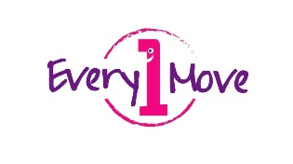
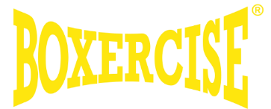
Boxing for Fitness and Fun
Every1Move is offering a 6 week class during the summer holiday, FREE of charge as part of my Community Give Back.
Boxing provides a full body high intensity low impact workout, helping also to improve coordination, speed and power as you progress. Boxing exercises are beneficial for muscle building, weight loss, and overall cardiovascular conditioning.
Classes have a mix of boxing moves, games along with other types of body weight exercises that create a fun and safe place for individuals.
Key benefits of fitness boxing
- It develops skills including hand-eye coordination, balance and timing
- It increases endurance, alertness and helps improve posture
- Strengthens upper body and core and enhances range of movement
- It is a great stress buster
- Reduced anxiety as the class will run online so they will be home
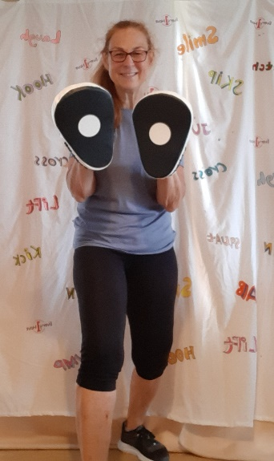
- Delivery and methods are adapted to suit those individuals involved
- Flexible and non-competitive to help encourage all to participate fully
- Inclusive to all building confidence in self
- Supports fun engagement in movement activities
You can dip in and out from week to week depending on your summer schedule. All you need for the class is a space to move and a bottle or glass of water. All exercises are done with no equipment. The class is animal friendly and I’m also happy for siblings, parents or even grandparents to join in with the session.
So…get ready to give me your best Jab and Cross and join me Tuesday mornings at 10.30 – 11.15.
Dates are: 27/7, 3/8, 10/8, 17/8, 24/8, 31/8
Boxing for Fitness and Fun Zoom details
https://us02web.zoom.us/j/89860660711?pwd=VEMwMm11RXl1QzVpMHM5cG4wQjNBUT09
Meeting ID: 898 6066 0711 Passcode: 452582
Please feel free to email me with any questions or just a yes please and I can send you the zoom information.
I look forward to hearing from you….. Shannon
shannon@every1move.com
Disclaimer - By taking part in this FREE session you confirm that you have not been advised by your GP or health professional to avoid any form of exercise, you do not suffer from chest pains at rest, during your daily activities or during any physical exercise, you do not suffer from dizziness or have lost consciousness in the last 12 months and that you take full responsibly for your own health and welfare during this session. Please contact me if you have any concerns regarding this disclaimer.

