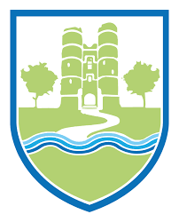
After the success of our Non-Fiction Bingo we are running another reading competition for the Christmas holiday!
Each time you complete a challenge, tick the box next to the challenge and colour in a bauble on the Christmas tree. Start at the bottom of the tree and make your way up to the top.
How many challenges can you complete before we come back to school?

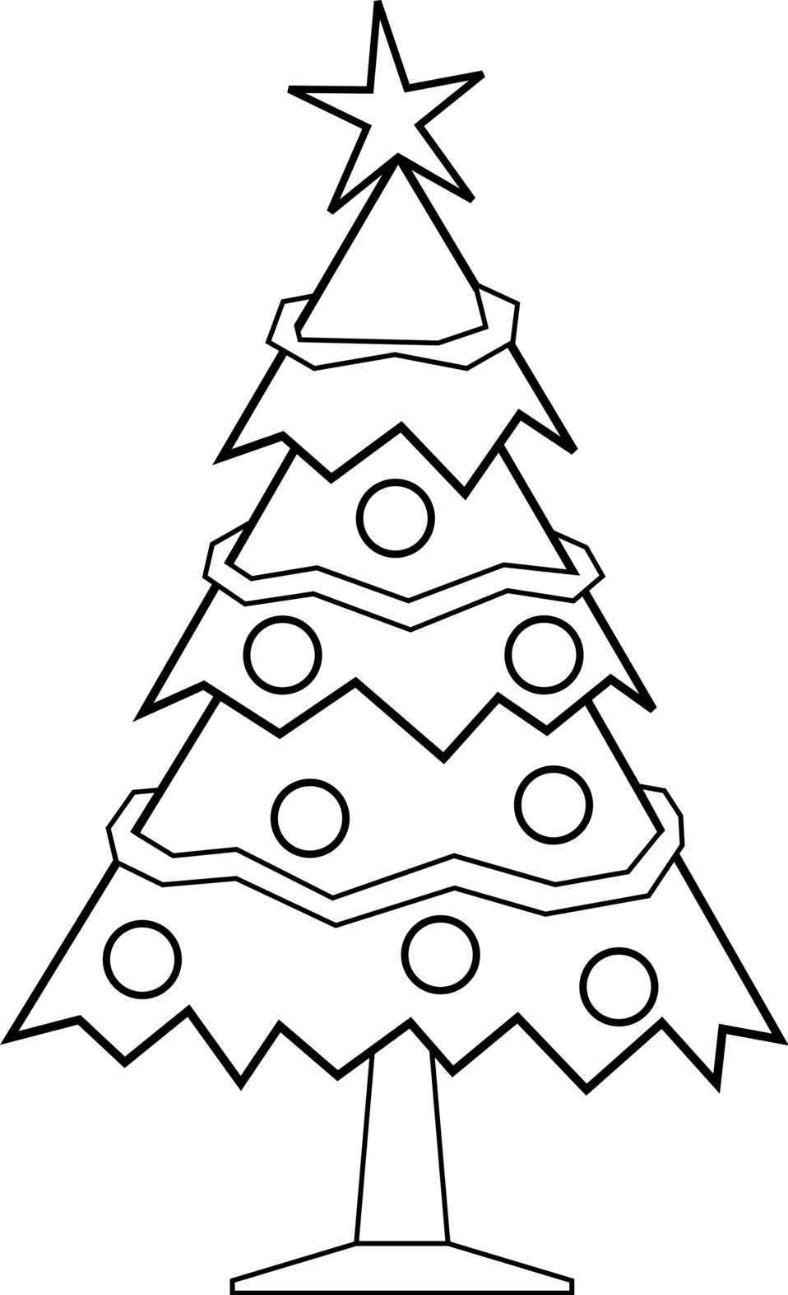

Again, for this challenge, the definition of ‘read’ can be reading to yourself, looking at something with a family member or a friend, having something read to you, listening to an e-book on Bug Club, or looking at the pictures. Remember that there are lots of things to read… You don’t have to read a ‘book’!

Read whilst wearing your pyjamas
Read something that has a Christmas theme
Read whilst sat in a chair
Read whilst drinking a milky drink
Read a Christmas card
Read in bed
Read some instructions
Read a recipe… may be you can even help with some baking!
Read to a pet or a toy

When we are back at school, show your teacher and then go and find Emily (in Colchester) to show her.

Happy reading and a happy holiday!

