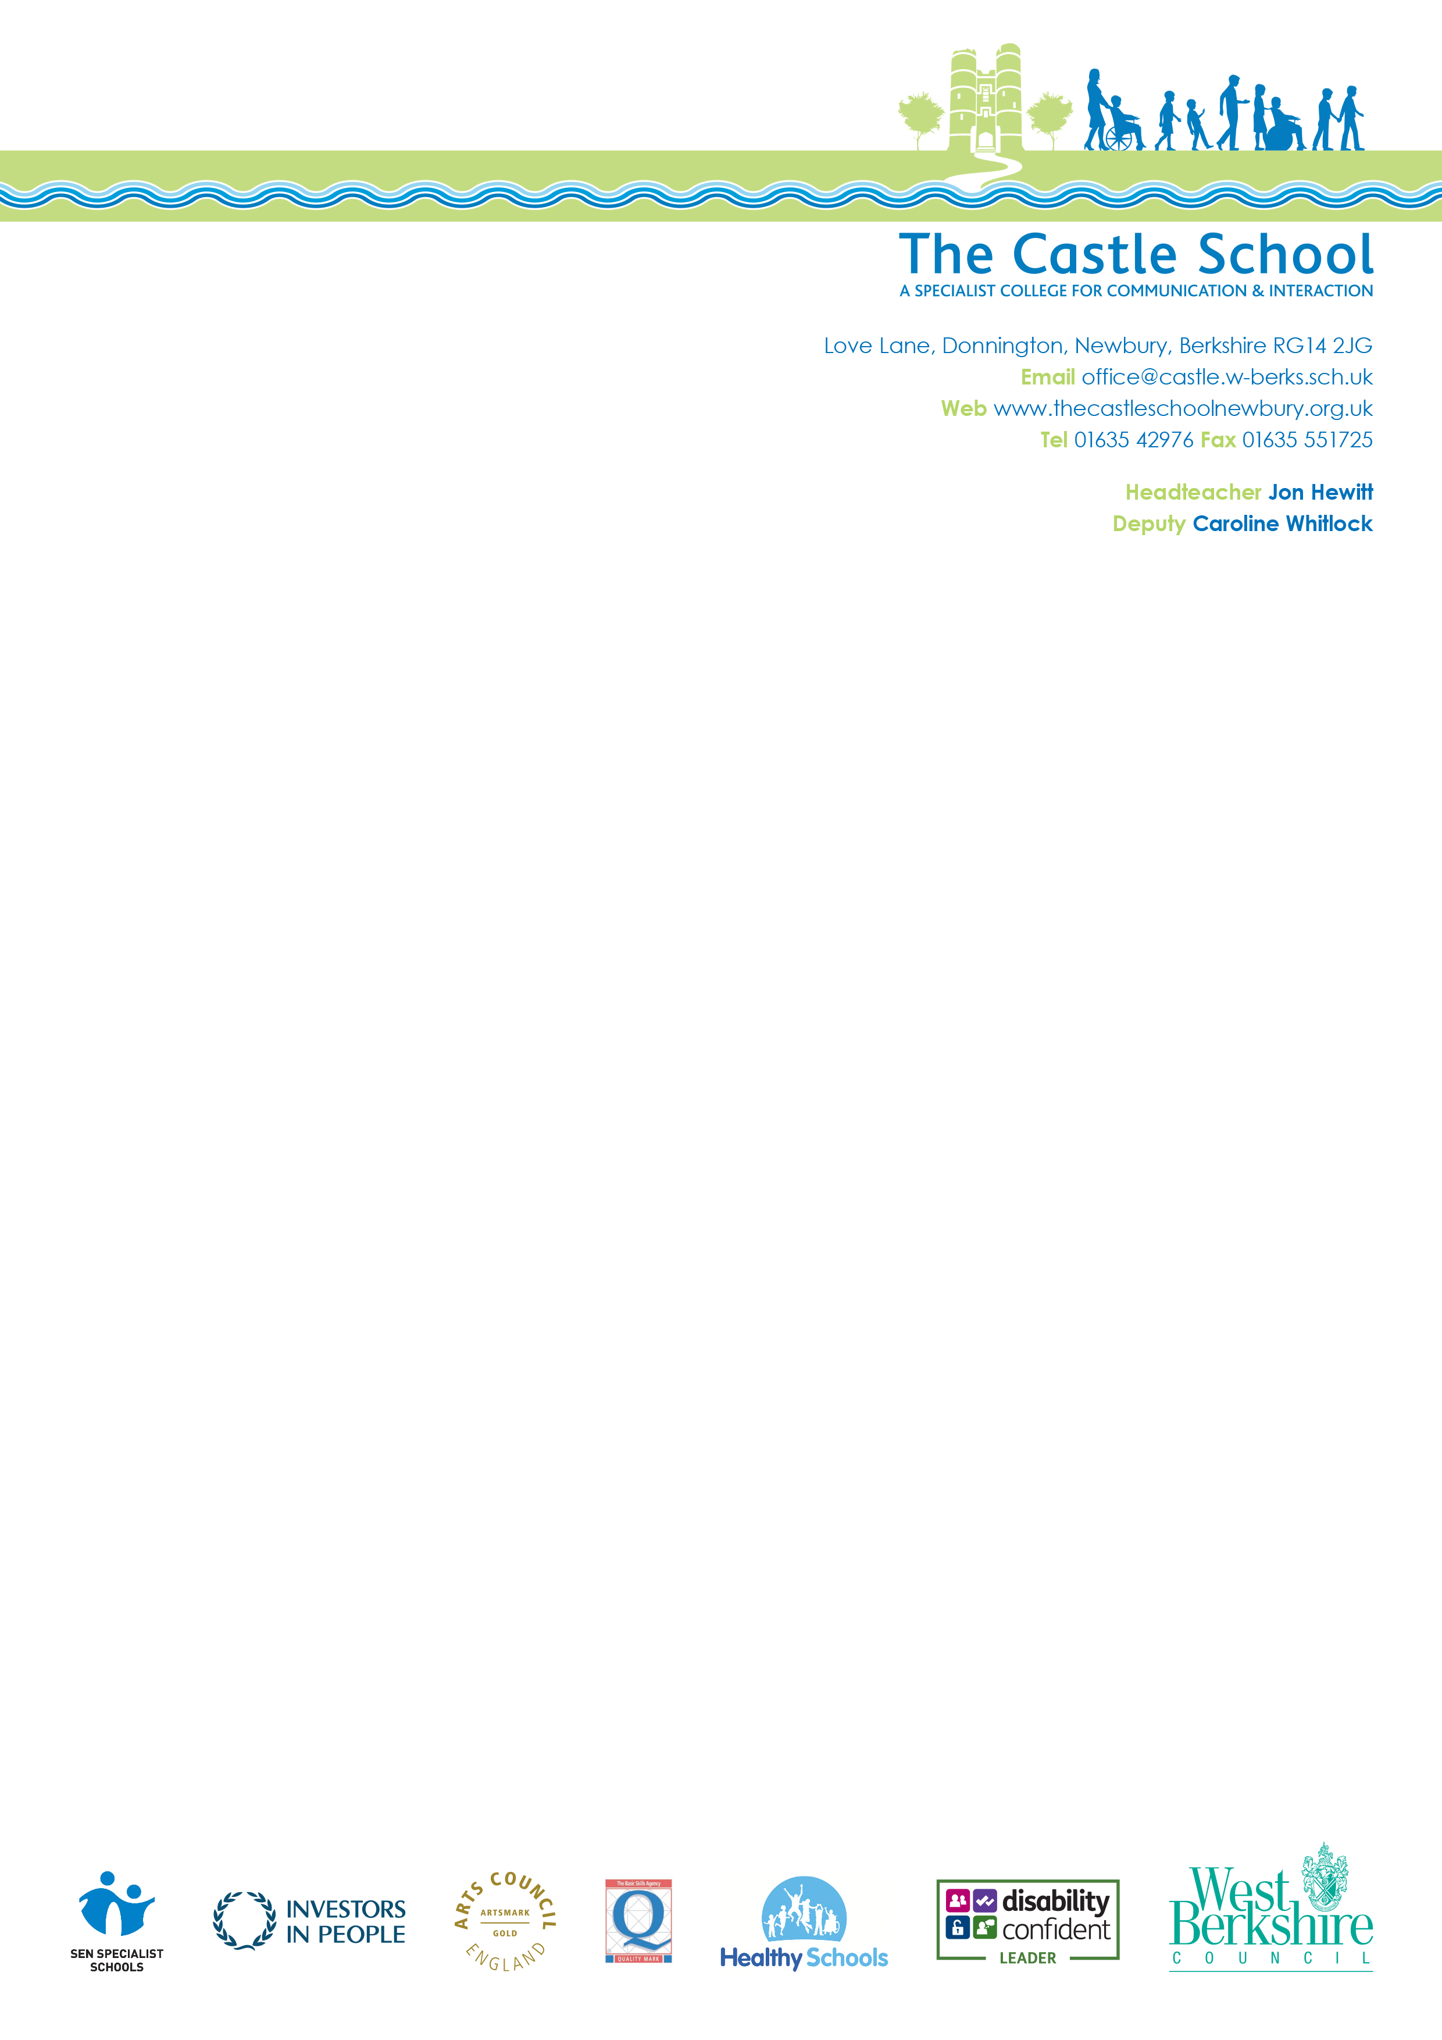
4th November 2024

Dear Parents and Carers,
Our School Council group would like to arrange a harvest collection for West Berkshire food bank next week. Please can you help us with the collection? We understand that things are tough at the moment, so please only donate if you are able to.
If you are able to make a donation, please send this in with your child to give to their class teacher by Monday 11th November. Please help by donating an item or two from the list below to support people facing hardship, to help the local community.
West Berkshire food bank would like the following items in particular.
Urgently needed:
- Lunchbox individual fruit juice
- Wet wipes
- Shaving foam
- Tinned veg
- Variety pack cereal
- Tinned meat meals – curry, hotpot, pies etc.
Low in stock
- Tinned fruit
- Tinned soup
- Honey
- Custard
- Rice pudding
- Long life puddings
- Tinned soup
Thank you for your support!
Kind Regards,
Hayley O’Donnell and P4PC (Pupils for Positive Change.)

Hayley O’Donnell
Windsor Class teacher

