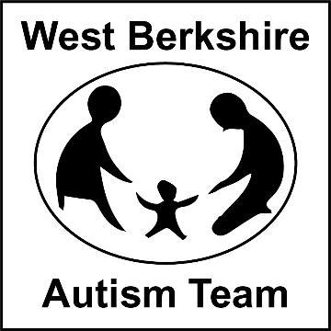**The Autism Team are having an Emotional Regulation Week (Commencing 24th May), where we will be running workshops for parents and schools, with advice sheets being emailed out in the same week. Please see below the events we are running for parents and professionals.**

**Emotional Regulation Week.**

**24th May to 28th May**

**25th May 2021 –** Understanding and Supporting Self-Regulation Skills in Young People

**C:\Users\mhutchings\AppData\Local\Microsoft\Windows\Temporary Internet Files\Content.IE5\IGTSGQCG\MC900437561[1].wmfTime: 7pm to 8.30pm**

**Venue: Zoom**

**Audience: Professionals and Parents**

**27th May 2021 –** Understanding and Supporting Self–Regulation Skills in Young People

**Time: 9.45am to 12noon**

**Venue: Zoom**

**Audience: Parents**

**Please contact Admin to book a place on: 01635 503646**

**Or email Learning Support Team**

[**LearningSupportTeam@westberks.gov.uk**](mailto:LearningSupportTeam@westberks.gov.uk)

**27th May 2021 –** Understanding and Supporting Self–Regulation Skills in Young People

**Time: 1.30-3pm**

**Venue: Zoom**

**Audience: Professionals**

**To book a place, please contact West Berkshire Training on:**

**C:\Users\mhutchings\AppData\Local\Microsoft\Windows\Temporary Internet Files\Content.IE5\HOEHME4T\MC900423153[1].wmfEmail:** [**Training@westberks.gov.uk**](mailto:Training@westberks.gov.uk)

**C:\Users\mhutchings\AppData\Local\Microsoft\Windows\Temporary Internet Files\Content.IE5\GF1FYXPC\MC900437563[1].wmf**

**Contact Details:**

The Autism Team 01635 503652 or

[learningsupportteam@westberks.gov.uk](mailto:learningsupportteam@westberks.gov.uk)